Objective

Describe how to work in Help Studio with multilingual content.

Scope

All topics and contents that are integrated to the Help system for the BCH web site.

References

HELP: (Innovasy Help Studio System):
http://www.innovasys.com/

4 Definitions
Locale
In computing, locale is a set of parameters that defines the user's language, country and any special variant preferences that the user wants to see in their user interface. Usually a locale identifier consists of at least a language identifier and a region identifier.

5 Content

For regular forms and popup dialogs HelpStudio will always show and edit the value for the currently selected Locale for any localizable fields. So when you have a specific locale selected, you don't need to do anything different from when you work in HelpStudio normally. For each localizable field, HelpStudio includes a Localize button next to the field that allows you to show the Localization dialog that allows you to view and edit the value of the field for each of the projects Locales.

Requirements
To work with locales their must be installed in the computer. Sometimes Arabic and Asian locales are not installed by default. To install those locales follow the steps described below (taken from Microsoft msdn).

- Go to Control Panel.
- Click on Date, Time, Language, and Regional Options.
- The Regional and Language Options applet appears.
- Click on the Languages tab.
- Install files for complex script and right-to-left languages and Install files for East Asian languages. The complex script and right-to-left languages include Arabic, Armenian, Georgian, Hebrew, the Indic languages, Thai, and Vietnamese; the East Asian languages include Chinese, Japanese, and Korean. The files for most other languages are installed on your computer automatically by Windows.
- Click OK or Apply.
- You will prompted to insert the Windows CD-ROM or point to a network location where the files are located.
- After the files are installed, you must restart your computer.

Create a locale
HelpStudio supports Unicode text throughout, supporting the creation of help content in any language supported by Windows.
In order to work with multilingual content in Help Studio you should have a locale for each desired language. To add a locale follow the steps described below.

- Click on Project>New Locale.
- On the New Project Locale dialog, select the Locale you wish to add;
- Click OK;
- The new Locale will be added to the project. The Locale will be listed under the Additional Locales section of the Project Explorer.
- Add the correct phrase to the locale (Sometimes a bug in Help Studio ) an incor. Go to Additional Locales in the Project Explorer, select the recently added locale and then

Add the correct phrase to a locale.
The output generated by HelpStudio, particularly for web help output, includes a number of standard phrases (e.g. "Table of Contents", "See Also"). For the standard 2005 and 2008 style templates, these phrases are available in English + 8 additional languages:
- Dutch
- German
- French
- Italian
- Spanish
- Russian
- Japanese
- Simplified Chinese
- Arabic
- English

Sometimes, a bug in Help Studio causes that a recently added locale has an incorrect phrase assigned to it. To add the correct phrase to a locale follow the steps described below.

- Go to Additional Locales in the Project Explorer.
- Double Click in the locale with the wrong phrase.
- In the box Phrase Language select the correct phrase.
- Click Ok.

Working with arabic content.

When you need to work with arabic content you need to change the template used in the help studio. To change the template you need to go to Project Settings and then select the Arabic template in the template tab.
After modifiying the template all the properties of the project in all languages are erased. The help project team has developed a little software to fill all the properties automatically. To run that program you must:

Save and close the project after you have changed the template.

Have the software installed: The installation is as easy as copy the propertiesadder folder under the Project plug-in folder in the svn server to the main folder of the Help Studio project that you are working with.
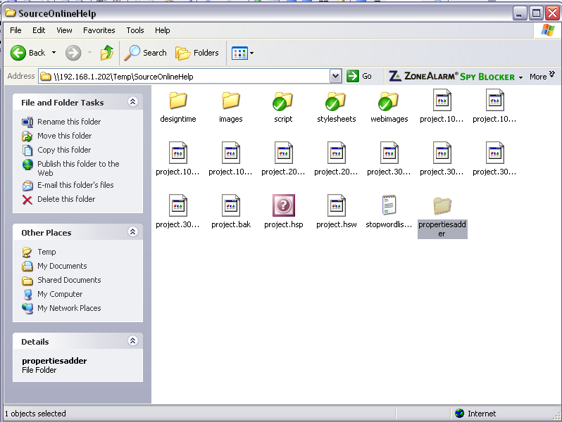

Execute the file HelpStudioAddin.exe.

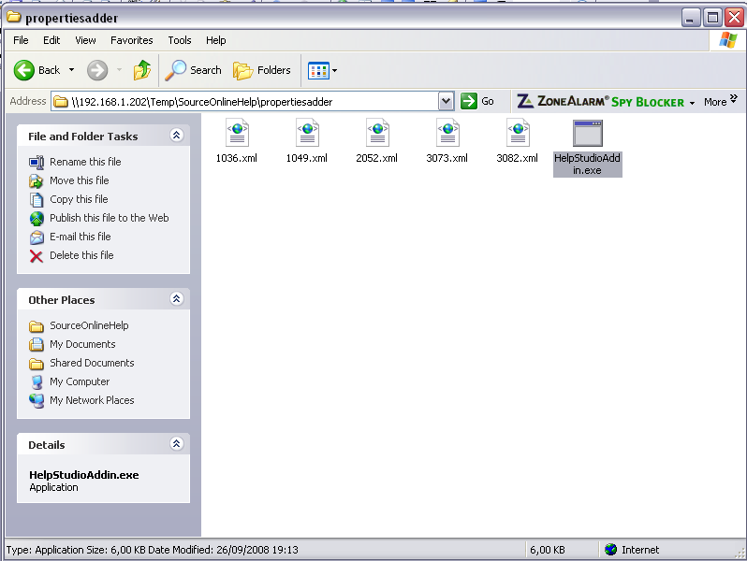

Re-open the help Studio and that is.

It’s important to remark that every time that the template is changed you need to follow the procedure explained below.

